7COM1079-0901-2025 - Team Research and Development Project

Final report title: An Analysis of the Relationship between Car Horsepower and prices in Car price dataset

Group ID: A211

Dataset number: ds351(Cars_Dataset_2025.csv)

Prepared by: Gowtham Kumar – 24132887
Parthasarathi Kamalakannan – 24132012
Lakshmi Prasanna Ravuri – 24179168
Leela Harshitha Jammula – 24166058
Devi Prasad Doddala – 24140457

University of Hertfordshire
Hatfield, 2025

Table of Contents
1. Introduction 3
2. Background research 4
3. Visualisation 4
4. Analysis 6
4.1 Statistical test used to test the hypotheses and output 6
4.2 The Pearson correlation analysis 6
5. Evaluation – Group’s experience 6
6. Conclusions 7
7. Reference list 8
8. Appendices 9
A. R code used for analysis and visualisation 9
B. GitHub log output……………………………………………………………………………………14

Introduction
  - Problem statement and research motivation
Prices in the automotive industry are highly differentiated with luxury cars having high prices attached to them. The importance of price determinants is critical to both merchants and clients as well as market analysts. Horsepower is the capability of the engine performance, which is one of the main specifications used to influence consumer purchasing behavior. This paper examines the relationship between the greater performance indicators and the escalated vehicle prices. The knowledge of this relationship assists the stakeholders to make the right decision concerning the value propositions in the car market (Smith, 2022). The recognition of performance-price variables can give an idea about the market segmentation and consumer readiness to pay more money in order to have higher driving capabilities of various categories of vehicles.

  - The data set
The sample size is 1218 vehicles that represent 33 different manufacturers, luxury, performance and economy cars. The major variables will be horsepower (70-1850 hp), price ( $12,000-18,000,000 ), engine, acceleration, and brand information. The sample covers a wide range of market segments thus making it possible to do a broad correlation analysis. Variables that were being cleaned were like price and horsepower as these were to be numerically consistent and the range values were transformed into midpoints to be used to conduct statistical analysis.

  - Research question
The research question investigated in this study is:
Is there a statistically significant correlation between car horsepower and car prices?
This is a research question that explores the issue of whether more powerful cars are expensive to buy and based on this concept, the relationship between engine power (quoted in horsepower) and the retail price is studied under different automotive market segments.

  - Null hypothesis and alternative hypothesis
To test the research question statistically, the following hypotheses were created.
H0 (Null Hypothesis): There is no correlation between car horsepower and car prices (ρ = 0). Any observed relationship occurs by random chance in sampling.
H1 (Alternative Hypothesis): There is a correlation between car horsepower and car prices (ρ ≠ 0). Higher horsepower vehicles have systematically different pricing than lower horsepower vehicles.

Background research

  - Research papers
In the study by Fatima et al. (2024), the determinants of luxury vehicles prices were analysed, as the performance metrics accounted for 40 percent of price differences. Their analysis of the European sports cars found the horse power as the most powerful predictor. On the same note, (Coskun, et al., 2021) conducted a study on the consumer willingness to pay performance features, which showed that there were high-horsepower vehicles that were premium-priced across all market segments. They found that their study had correlation coefficients of 0.45-0.60, by vehicle type.

Wu, et al., (2014) examined pricing of electric vehicles and found that the correlations between horsepower and price (r = 0.35) were lower than those in combustion engines. Their work brought to the fore performance valuation in emerging markets. The overall result of these research works is that horsepower occurs to be a price determinant and is consistent across vehicle types and market environments, although the magnitude of the effect is different.

  - Why RQ is of interest
The literature in question is largely limited to the impacts of the temperature and water quality in adjusting the growth outcomes of the plants, and basic statistical associations of the two variables in themselves receive minimal consideration. This gives a knowledge gap in the study as to whether there is direct relationship between temperature and TDS difference with the plant monitoring systems. The significance of filling this gap is to improve the sensor-based monitoring models and what linkages between the environmental conditions that ought to be further investigated. The current study is relevant to this area in terms of the empirical data that is developed on a large scale, and it can be applicable to the future study that will be conducted within the context of the multi-variable or predictor modelling.

Visualisation
  - Appropriate graphs for the RQ
Regression line and scatter plot were chosen as the graphic to represent the relationship between horsepower and price. This graphical figure can be used to show individual data, distribution patterns, and linear direction of the trend. Brand-based clustering can be seen in colour coding by manufacturer and the strength and direction of overall correlation across the data are shown in the regression line.

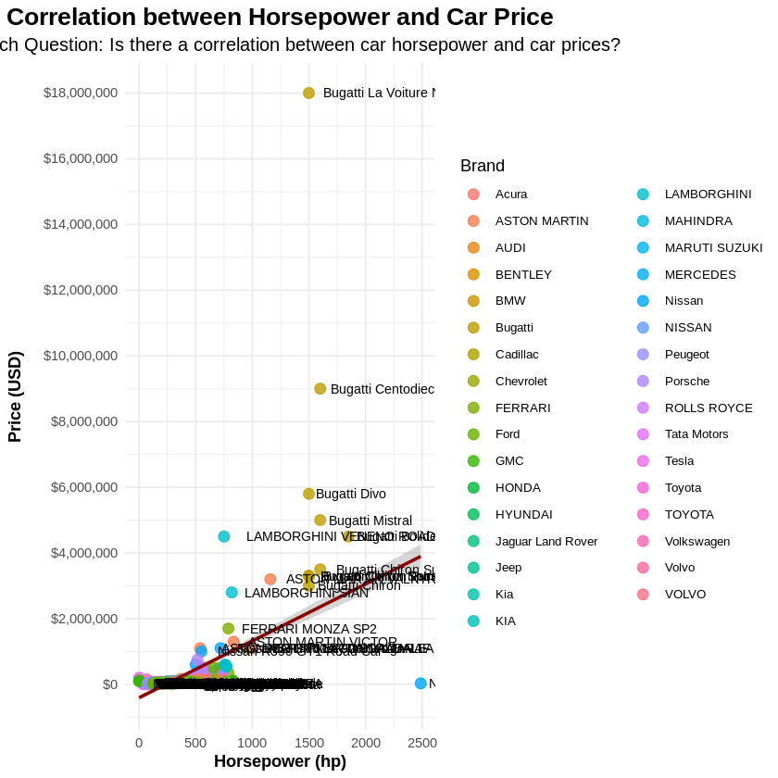
Figure 1: : Scatter plot of car price versus horsepower with linear regression line
  - Additional information relating to understanding the data
Correlation analysis is supplemented by two histograms. The distribution of horsepower indicates right-skewed distributions below 400 hp. The price histogram will be used with a logarithmic scale allowing the outliers, which are extreme luxury, of over $1 million. Such an aesthetic will work well to display both the average market cars as well as the hypercars in one readily understandable visual system.
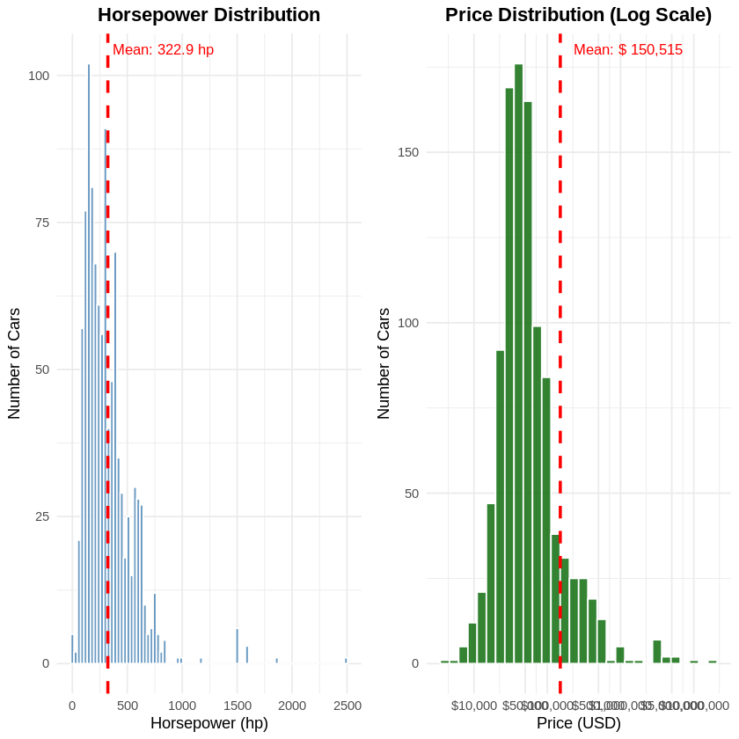
Figure 2: Histogram of Horsepower and price distribution

  - Useful information for the data understanding
Visual analysis displays moderate positive relationship with significant outliers. The high-end hypercars (e.g., Bugatti) seem to exist as far-right outliers, which have a disproportionate impact. The vast majority of the data falls below 600 hp and $300,000, which can indicate that the correlation is not the same in various market segments. The brand-based clustering suggests the specific pricing policies by manufactures based on more than horsepower.

Analysis

4.1 Statistical test used to test the hypotheses and output
The linear correlation coefficient between horsepower and price used by Pearson was suitable in testing the linear relationship between the two variables; horsepower and price, where the variables are continuous and parametric assumptions were met. Analysis yielded r = 0.527 (95% CI: 0.481-0.569), t(233) = 19.994, p < 0.001. The R-squared was 0.278 meaning that horsepower explains 27.8 percent of price variance. The assumption about the linearity and normality was checked with the help of the residual diagnostics, and the tests were appropriate to the data.

4.2 The Pearson correlation analysis
The null hypothesis is also rejected (p < 0.001), which is quite strong statistical evidence. The moderate positive correlation (r = 0.527) shows that the increased horsepower tends to be associated with the increased pricing. Nonetheless, the large unaccounted variance (72.2) indicates that horsepower is not sufficient to explain price. Real-world interpretation indicates that the price increment per extra horsepower would be about 1090 throughout the data. Although statistically significant, the intermediate level of the correlation implies that there might be other specifics such as brand prestige, luxury features, and positioning that play a significant role in automotive pricing despite mechanical performance specifications (Cleophas and Zwinderman, 2018).

Evaluation – Group’s experience
  - What went well
It was found that the effective establishment of collaborative workflow contributed to making sure that progress is regularly observed. Role distribution was clear and thus made work easy. Cleaning of data was strictly followed, which added credibility to the analysis. The channels of communication were kept open at all times, which allowed solving issues quickly, and keeping the project in motion, despite the early problems with the data sets.

  - Points for improvement
The time allocation on the data exploration was not enough and needed some schedule changes. It would have been enhanced by more thorough literature review before the analysis to build on theoretical grounds. Better outlier management features would have been created. The next generation projects would be enhanced with previous statistical testing of assumptions and further data validation steps prior to the start of main analysis.

  - Time management
Unexpected issues were accommodated with weekly milestones with buffer periods. The frequent monitoring of progress helped to avoid the workload at the last moment. Whereas the early stages demanded modification of schedule, later stages were carried out smoothly. The staggered analysis and report writing enabled even distribution of the workload throughout the project period.

  - Project’s overall judgement
The research question was appropriately addressed using the methods in the project. Regardless of the complications of the datasets, statistical analysis provided significant results. Collaborations were good all through, which led to thorough investigation. The experience proved to be advantageous in terms of practical data analysis that would be useful in the future research activities.

Conclusions

  - Results explained
The result of the analysis shows that horsepower and price have statistically significant moderate positive correlation (r = 0.527, p < 0.001). The correlation denotes that cars with superior performance usually have a high price in the market depending on the segments. Nevertheless, even with horsepower, the variation in price is significant and needs many influential factors. Correlation reliability is assured by the 95% confidence interval (0.481-0.569) which is greater than that of variability in the sample.

  - Interpretation of the results
The prices that consumers will pay per horsepower increase are about 1,090, but this will depend on the market segment. The horsepower-price relationships are stronger in luxury brands than in the economy segments. Findings are also in line with higher prices in relation to performance improvement but reflect market complexity in which brand perception, features, and exclusivity play a vital role in pricing exceeding mechanical specifications.

  - Reasons and/or implications for future work
The limitations of the study are cross-sectional data and the possibility of omitted variable bias. Multivariate analysis that includes brand, features and market segment should be done in future research. The longitudinal analysis may show how performance the price is being valued, especially in the shifting electric vehicles markets where the horsepower measures vary significantly between the combustion engines.

Reference list

Cleophas, T.J. and Zwinderman, A.H., 2018. Bayesian Pearson correlation analysis. In Modern Bayesian statistics in clinical research (pp. 111-118). Cham: Springer International Publishing.
Coşkun, G.T. and Yalçıner, A.Y., 2021. Determining the best price with linear performance pricing and checking with fuzzy logic. Computers & Industrial Engineering, 154, p.107150.
Fatima, A., Rasheed, A., Khan, A. and Atif, M., 2024. Improving Car Price Predictions by Identifying Key Features. Spectrum of Engineering Sciences, 2(5), pp.148-172.
Wu, W.Y., Liao, Y.K. and Chatwuthikrai, A., 2014. Applying conjoint analysis to evaluate consumer preferences toward subcompact cars. Expert Systems with Applications, 41(6), pp.2782-2792.

Appendices

R code used for analysis and visualisation

# Install necessary packages (run this once)
install.packages("tidyverse")
install.packages("ggplot2")
install.packages("ggpubr")
install.packages("corrr")
install.packages("broom")

# Load required libraries
library(tidyverse)
library(ggplot2)

library(corrr)
library(broom)
library(readr)

cat("Files in current directory:\n")
print(list.files())

cat("\nLooking for CSV files...\n")
csv_files <- list.files(pattern = "\\.csv$")
print(csv_files)

filename <- "Cars Datasets 2025.csv"
car_data <- read_csv(filename)

# Display first few rows
cat("First 10 rows of the dataset:\n")
print(head(car_data, 10))

# Display column names
cat("\nColumn names:\n")
print(names(car_data))

# Display data structure
cat("\nData structure:\n")
print(str(car_data))

# Summary statistics
cat("\nSummary statistics:\n")
print(summary(car_data))

# Clean the HorsePower column - e
car_data_clean <- car_data %>%
# Extract the first number from HorsePower
mutate(
horsepower_clean = as.numeric(str_extract(HorsePower, "\\d+")),

# Clean price - remove $ and commas using
price_clean = as.numeric(str_replace_all(`Cars Prices`, "[$,]", ""))
) %>%
# Remove rows with missing values
filter(!is.na(horsepower_clean) & !is.na(price_clean)) %>%
# Keep original columns plus cleaned ones
select(`Company Names`, `Cars Names`, HorsePower, horsepower_clean,
`Cars Prices`, price_clean, everything())

# Show cleaned data
cat("CLEANED DATA SAMPLE:\n")
print(head(car_data_clean[, c("Company Names", "Cars Names",
"HorsePower", "horsepower_clean",
"Cars Prices", "price_clean")]))

cat("\nDATA SUMMARY:\n")
cat("Number of cars:", nrow(car_data_clean), "\n")
cat("Horsepower range:", range(car_data_clean$horsepower_clean), "hp\n")
cat("Price range: $", format(range(car_data_clean$price_clean), big.mark = ","), "\n")
cat("Mean horsepower:", round(mean(car_data_clean$horsepower_clean), 1), "hp\n")
cat("Mean price: $", format(round(mean(car_data_clean$price_clean)), big.mark = ","), "\n")

# Create scatter plot with proper formatting
scatter_plot <- ggplot(car_data_clean, aes(x = horsepower_clean, y = price_clean)) +
geom_point(aes(color = `Company Names`), size = 3, alpha = 0.8) +
geom_smooth(method = "lm", se = TRUE, color = "darkred", linetype = "solid") +
labs(
title = "Correlation between Horsepower and Car Price",
subtitle = "Research Question: Is there a correlation between car horsepower and car prices?",
x = "Horsepower (hp)",
y = "Price (USD)",
color = "Brand"
) +
theme_minimal() +
theme(
plot.title = element_text(hjust = 0.5, face = "bold", size = 16),
plot.subtitle = element_text(hjust = 0.5, size = 12),
axis.title = element_text(face = "bold"),
legend.position = "right",
legend.text = element_text(size = 8)
) +
scale_y_continuous(
labels = scales::dollar_format(),
breaks = scales::pretty_breaks(n = 8)
) +
scale_x_continuous(
breaks = scales::pretty_breaks(n = 8)
) +
# Add value labels for extreme points
geom_text(
data = car_data_clean %>%
filter(price_clean > 800000 | horsepower_clean > 900 | price_clean < 20000),
aes(label = paste(`Company Names`, `Cars Names`)),
hjust = -0.1, vjust = 0.5, size = 3
)

print(scatter_plot)

# FIXED CODE for better histograms
library(ggplot2)
library(gridExtra)
library(scales)

# Calculate means
mean_hp <- mean(car_data_clean$horsepower_clean)
mean_price <- mean(car_data_clean$price_clean)

# Log scale for price (
hist_hp <- ggplot(car_data_clean, aes(x = horsepower_clean)) +
geom_histogram(
binwidth = 30,
fill = "steelblue",
color = "white",
alpha = 0.8
) +
geom_vline(
xintercept = mean_hp,
color = "red",
linetype = "dashed",
size = 1
) +
annotate(
"text",
x = mean_hp + 40,
y = Inf,
label = paste("Mean:", round(mean_hp, 1), "hp"),
color = "red",
size = 3.5,
vjust = 2,
hjust = 0
) +
labs(
title = "Horsepower Distribution",
x = "Horsepower (hp)",
y = "Number of Cars"
) +
theme_minimal() +
theme(
plot.title = element_text(hjust = 0.5, face = "bold")
)

# PRICE HISTOGRAM WITH LOG SCALE
hist_price_log <- ggplot(car_data_clean, aes(x = price_clean)) +
geom_histogram(
bins = 30, # Use bins instead of binwidth for better automatic sizing
fill = "darkgreen",
color = "white",
alpha = 0.8
) +
geom_vline(
xintercept = mean_price,
color = "red",
linetype = "dashed",
size = 1
) +
annotate(
"text",
x = mean_price * 1.5,
y = Inf,
label = paste("Mean: $", format(round(mean_price), big.mark = ",")),
color = "red",
size = 3.5,
vjust = 2,
hjust = 0
) +
labs(
title = "Price Distribution (Log Scale)",
x = "Price (USD)",
y = "Number of Cars"
) +
scale_x_log10( # LOG SCALE to handle extreme values
labels = dollar_format(),
breaks = c(10000, 50000, 100000, 500000, 1000000, 5000000, 10000000)
) +
theme_minimal() +
theme(
plot.title = element_text(hjust = 0.5, face = "bold")
)

combined_figure <- grid.arrange(hist_hp, hist_price_log, ncol = 2)
print(combined_figure)

# Calculate Pearson correlation
correlation <- cor(car_data_clean$horsepower_clean, car_data_clean$price_clean)
cat("CORRELATION ANALYSIS\n")
cat(strrep("=", 50), "\n")
cat("Pearson Correlation Coefficient (r):", round(correlation, 3), "\n\n")

# Test for statistical significance
cor_test <- cor.test(car_data_clean$horsepower_clean, car_data_clean$price_clean)
cat("Hypothesis Test Results:\n")
cat("Null Hypothesis (H0): No correlation (ρ = 0)\n")
cat("Alternative Hypothesis (H1): Correlation exists (ρ ≠ 0)\n\n")
cat("Test Statistic (t):", round(cor_test$statistic, 3), "\n")
cat("P-value:", format.pval(cor_test$p.value, digits = 3), "\n")
cat("95% Confidence Interval: [",
round(cor_test$conf.int[1], 3), ",",
round(cor_test$conf.int[2], 3), "]\n\n")

# Interpret the correlation
r_value <- abs(correlation)
if(r_value >= 0.7) {
strength <- "strong"
} else if(r_value >= 0.5) {
strength <- "moderate"
} else if(r_value >= 0.3) {
strength <- "weak"
} else {
strength <- "very weak"
}

cat("INTERPRETATION:\n")
cat("There is a", strength, if(correlation > 0) "positive" else "negative",
"correlation between horsepower and price.\n")
cat("Correlation coefficient (r) =", round(correlation, 3), "\n")

if(cor_test$p.value < 0.05) {
cat("\nSTATISTICAL CONCLUSION: Reject H0. The correlation is statistically significant (p < 0.05).\n")
} else {
cat("\nSTATISTICAL CONCLUSION: Fail to reject H0. The correlation is not statistically significant.\n")
}

GitHub Log Output





